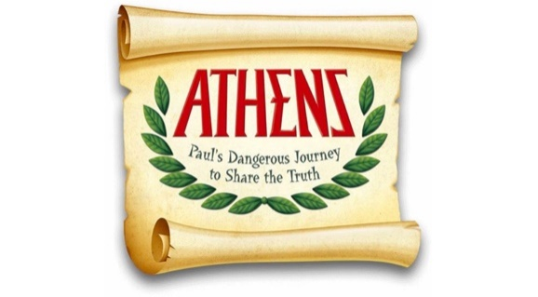

Dear Parents,

Welcome to Athens VBS, where you will join Paul on his dangerous journey to share the truth! We are so glad that you have chosen this amazing experience that will help children and adults explore ancient Athens and the Holy Lands through the eyes of Paul. At Athens VBS, each participant (ages pre-K – adults) will be placed with an Oikos family who will travel together to worship, make an art craft, play arena games, learn about Athenian culture, explore the Marketplace, visit Paul in his tent-making house, and dig into Scripture. Oikos families will also eat snacks together and participate in opening and closing ceremonies each night, and be involved with a mission project.

It is our prayer that Athens VBS will allow God's Word to come to life like never before, toughing lives, changing hearts, and drawing kids and adults closer to Christ. May God guide and bless you on this Holy Land Adventure as you join Paul on his dangerous journey to share the truth!

Nightly Schedule:
6:00 - 6:15 pm: Celebration - Opening Ceremony
6:15 - 6:30 pm: Bible Message
6:30 - 6:45 pm: Paul's Adventures, Arena Games
6:45 - 7:00 pm: Arena Games, Paul's Adventures
7:00 - 7:15 pm: Marketplace
7:15 - 7:30 pm: Marketplace
7:30 - 7:45 pm: Celebration - Closing Ceremony
7:45 - 8:00 pm: Oikos Time

Join us at Carlisle Avenue Baptist Church
on August 11 - 15, 2019
from 6 - 8 pm.

To register or to find out more about Athens VBS, please fill out a registration form with a pen or call the church office at 222-4140 or visit the church website at www.cabcva.org. Be sure to like CABC's Facebook page at www.facebook.com/cabcva to receive future updates about our events.

Sincerely,

Claire George
Minister to Families at Carlisle Avenue Baptist Church

